**EMS Report**

Deputy Chief Mike Lepin

January 14, 2024

1. **Jefferson County ASA Plan**: Next Jefferson County ASA Committee meeting is on February 18th. We will be reviewing the changes made by Alexa and me then.
2. **Wasco County ASA Contract:** I’m requesting permission to sign the amended ASA contract with Wasco County. Our ASA in Wasco County takes us up to the Hwy 97/197 junction, covering Antelope and the Washington Family Ranch.
3. **Transport Ventilators**: We will receive our grant funding ($15,000) from SCMC sometime this month, then we will order the new ventilators.

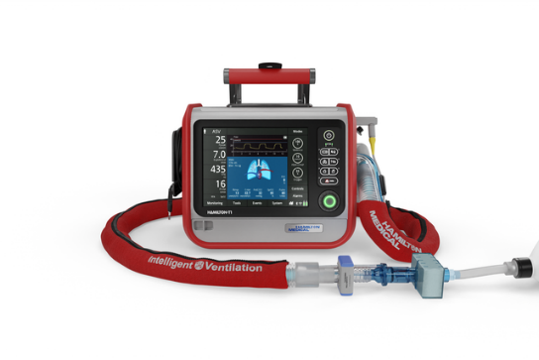

We will have an all-day training session on them in February and expecting deployment of them the first week of March.

1. **Inter-Facility Transfers:** I met with Todd Schields who manages SCMC-Madras and Prineville last Friday to discuss Inter-facility transfers. We talked about the history of these transfers, where we are now and what our goals are. One of the goals is to return to doing night transfers. To see how much money we are missing, Todd said he will get me the numbers of how many calls we are missing at night.

I also asked if SCMC would be willing to revisit paying us a stipend for doing transfers like they do for Adventure Medics. He said yes for night transfers and will work with their financial person to see what that number will look like. We will meet again soon to see what those numbers and dollars will look like.

1. **City of Fossil Ambulance Issues**: There have been some positive changes. I spoke with 3 different state representatives, including Rep Grayber, and a state senator about the woes of Fossil and shared a couple ideas, one being a Community Paramedic who could also work in the clinic and help with reduction of visits like they do for the hospitals. I’m not sure if this helped but I found out that the clinic in Fossil has applied for a grant to fund 2 Integrated-Health (Community Paramedics) to respond on ambulance calls as well as work in the clinic. Fossil Ambulance still has 4 people in the EMT class and Spray Ambulance is still assisting by responding to calls until Fossil is up and running again.
2. **Oregon State Ambulance Association (OSAA) & Balanced Billing**: This initiative bans balance billing, which saves the patient money, yet increases what ambulance providers receive from insurance, allowing payment for established rates or 400% of the Medicare rate (which theoretically is similar). See attached advertisement.

Since our last meeting, Rep Nosse, Chair of the Behavior Health and Health Care Committee, asked insurers to provide their suggested edits to LC 711. Their edits removed the reimbursement rate section entirely – this will ban balance billing for EMS providers but is silent on reimbursement rates. This could be detrimental.

The insurers added a new definition for services which will allow for transport of behavioral health emergencies to the appropriate facility (can be good); except, they are also narrowing the definition of healthcare facility (which can be a problem).

Insurers also want to remove the $100 cap on out-of-pocket costs, instead saying you can’t bill beyond the in-network cost sharing amount that is specified by the plan.

These edits, specifically about the silence on reimbursement rates, are not acceptable to the OSAA’s Balance Billing Subcommittee and we have asked Rep Nosse to push back.

This is what I meant about not expecting this to go through as fast as mentioned before.